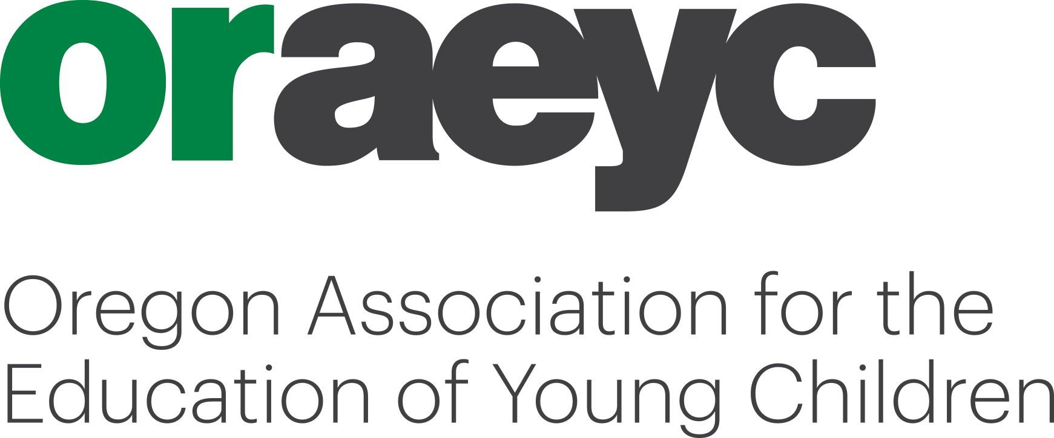
Spring Conference 2021 Presenter Application

In response to the continuing COVID-19 situation, our Spring Conference will be taking place virtually this year.

The spring conference will happen in the zoom platfrom over an 8 day period- Friday April 30- Saturday May 8 We will offer participants morning, afternoon and evening options.
We are accepting a variety of sets with priority given to Set Two and Set Three sessions.

It is preferred that presenters have experience in presenting virtually, but it is not mandatory.

ORAEYC Conference Purposes
- Provide training and resources for all who work with children and families.
- Embrace diversity, counteract bias and adopt inclusive practices.
- Promote partnerships, networking and collaboration between families, providers, schools, agencies and the community.
- Enhance the professional development of all participants.

Criteria: Presentations will be selected based on the following criteria:
- Incorporates anti-bias principles, developmentally appropriate practice and culturally sensitive practices. The concept of developmental appropriateness has three dimensions:
Age appropriateness -- Knowledge of age-related human characteristics that permit general predictions within an age range of what activities, materials, interactions, or experiences will be safe, healthy, interesting, achievable, and challenging to children;
Individual Appropriateness -- Knowledge about the strengths, interests, and needs of each individual child in the group to be able to adapt for and be responsive to inevitable human variation; and
Social and Cultural Appropriateness – Knowledge of the social and cultural contexts in which children live to ensure that learning experiences are meaningful, relevant, and respectful for the participating children and their families.
- Reflects hands-on experiences as well as applied research and offers achievable outcomes for participants.
- Content can be applied without using a specific product or service – presentations that are a “sales pitch” will not be considered. Presenters who have materials to sell will receive a complementary space on our conference vendors & sponsor page.
- Presenter has educational and work experience related to the core knowledge area addressed by the presentation, experience teaching adults and knowledge of adult learning
Conference Honoraria: Set One & Set Two: The primary workshop presenter receives a choice of honoraria; either $50 (per 2 hour session) or $75.00 (per three hour session) or an NAEYC/ORAEYC Standard membership. If there is a co-presenter, they are entitled to an NAEYC/ORAEYC Standard membership upon request. Set Three: The primary presenter receives either a $100 honorarium or an NAEYC/ORAEYC Premium Membership (per 3 hour session) . If there is a co- presenter, they will receive the Standard NAEYC/ORAEYC membership upon request.
Deadlines: Priority is given to those proposals received by March 5th, 2021. All application are reviewed by the Conference Committee. Applications received after deadline will be considered on a space-available basis. Applicants will be notified by March 12th. Mail to: ORAEYC, PO Box 60, Gladstone, Oregon 97027, email to sara@oregonaeyc.org or fax to 503-496-0520.
For More Information please contact ORAEYC at 503-496-3991 or email Sara. We appreciate your support of ORAEYC and sharing your expertise with the diverse childhood care and education community.
Application to Present – Spring 2021: Page 1 of 2

PRIMARY PRESENTER

Name: _______________________________________________ Affiliation/Qualifications: _________________________________
(i.e. AA, BS, MA, Oregon Registry Community or Master Trainer)

Address: _________________________________________________ City: ___________________ State: _____ Zip: ____________

Work: (_____) _________________ Home: (_____) __________________ E-mail: ________________________________________
Co-Presenter (if applicable)

Name: _______________________________________________ Affiliation/Qualifications: ___________________________________

Address: __________________________________________________ City: ___________________ State: _____ Zip: _____________

Work: (____) ________________ Home: (_____) _________________ E-mail: ____________________________________________

Logistical Information:

AVAILABILITY: Please indicate when you are available to give your presentation (check all that apply):
DAY/S: ☐ Monday ☐ Tuesday ☐ Wednesday ☐ Thursday ☐ Friday ☐ Saturday
TIME: ☐ 9:00- noon ☐ 1:00- 4:00pm ☐ 6:00- 9:00pm
- Sessions can be shorter in length, but held in these time slots. Please indicate the session length if it is shorter than 3 hrs (here) ____________.
- Sessions can be longer in length. Please indicate the session length if it is longer than 3 hours:_________.

PREFERRED ENROLLMENT LIMIT: (Registered participants have access to all sessions. If your session requires a maximum number set due to content delivery concerns, please mark the box below and give us the max. number you can accommodate.)
☐ ________(max. enrollment)

PRESENTER COMFORT LEVEL IN VIRTUAL TRAINING: ☐ New format to me ☐ Limited experience in virtual training ☐ Very comfortable in virtual training

I WILL REQUIRE TRAINING IN PROVIDING A VIRTUAL PRESENTATION:
☐ NO ☐ YES
☐ ensuring my normally face-to-face training meets OCCD criteria for virtual training ☐ in developing small group breakout groups ☐ Other: please describe:

HAND-OUTS: Please send ORAEYC a copy of you handouts by April 23rd. You will have the ability to “drop” your files into your session for participants.

HONORARIA PREFERENCE: Please choose ONE
☐ Donate my time
☐ ORAEYC/NAEYC Membership (s) for _________________________________/_____________________________
☐ Honorarium(s) to: ________________________________________/________________________________________
☐ Donate my honoraria to the Merrily Hass scholarship porgram

EXHIBIT SPACE: (indicate if you want a complimentary virtual exhibit space with vendors/sponsors on the conference page of our website)
☐ YES ☐ NO
Workshop Information: Page 2 of 2
PRESENTATION HISTORY If you have not presented for ORAEYC during the past few years, please attach a professional reference or name of a conference or training where you were a presenter; include name and phone number of contact person. If you have questions about the Oregon Registry and the Registry Trainer system, call the Oregon Center for Career Development at 503-725-8535 or 1-877-725-8535 or visit www.pdx.edu/occd

Has your workshop been pre-approved by the Oregon Registry Trainer Program? ☐ Yes ☐ No
If yes, approved Title: ___________________________________________________ Set: ______ CKC:_________ Age(s):______
(If YES, you may submit your Oregon Registry Training Proposal form instead of this page.)

Level of Presentation: (You must have a Bachelor’s degree, Oregon Registry Step 10 or equivalent to offer a Set 2 or 3 training).
☐ Introductory - Set One – overview, define, explain, discuss, understand
☐ Intermediate - Set Two – application, development, examination, exploration, implementation, practice, selection
☐ Advanced - Set Three – critical examination through in-depth study, conducting research, strategies, theory

AGE GROUP FOCUS OF PRESENTATION: Check the most applicable, but no more than three.
☐ Ages 0-3 Infants and Toddlers ☐ Ages 3-5 Preschool
☐ Ages 5-8 Kindergarten/Primary
☐ Ages 5-12 School Age Care and Enrichment and Elementary
☐ Adult Learning and Development
☐ Not applicable

Indicate Core Knowledge Category. If you choose more than 1 category, please indicate the number of hours for each category.
☐ Diversity____
☐ Families & Community Systems____
☐ Health, Safety & Nutrition____
☐ Human Growth & Development____
☐ Learning Environments & Curriculum____
☐ Observation & Assessment____
☐ Personal, Professional & Leadership Development____
☐ Program Management____
☐ Special Needs____
☐ Understanding & Guiding Behavior____

Language of Presentation: □ English □ Spanish □ Other (please list): _________________________
We recommend that all presenters speak English, either as a first or second language. If presenting in another language, your workshop title and description must be written in both English and the other language.

WORKSHOP INFORMATION We reserve the right to edit proposal titles and descriptions. Either attach a separate sheet with the following information or expand the spaces. Please adhere to word limit.

A. TITLE (60 CHARACTER LIMIT)

B. DESCRIPTION FOR BROCHURE (60 word limit) Please help participants know what to expect from your presentation: what will it cover - how will it be covered - who should be interested? Make you description short and enticing.

C. Workshop Objectives (1 to 3 per session) to be used for evaluations Samples: I practiced two strategies to enhance language development. I learned five baby signs. I can describe the importance of communicating with families.

D. Brief outline of your presentation including at least one reflective activity and one professional action activity.
Examples of reflective activities include: “write down a recent example of a challenging behavior” or “write or draw about a time when…”
Examples of professional action: “tell someone at your table what you will implement from this session” or “record a personal/professional commitment based on this training.”
E. Cite at least one current professional reference or resource (book, journal article, etc.) used in developing this session.

Please return by March 5, 2021 for consideration:
ORAEYC Proposals • PO Box 60 • Gladstone • OR 97027
or FAX: (503) 496-0520 or E-mail: sara@oregonaeyc.org
we will accept late applications as space is available

