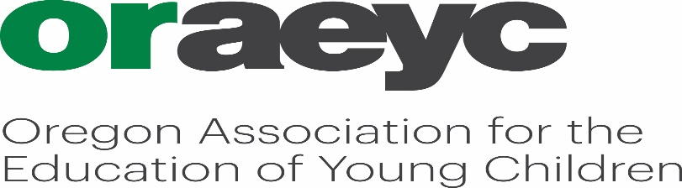

Mind in the Making Information & Registration Form

Where: Virtual Zoom sessions (8 sessions)
When: Thursday evenings 6:00-8:30pm (Jan. 20- March 10)
January 20th & 27th
February 3rd, 10th, 17th, & 24th
March 3rd & 10th

Cost: $200.00 for current ORAEYC members $ 230.00 For Community Members
$270.00 for Cohort & NAEYC Standard Membership

This cohort qualifies for Betty Gray Leadership Cohort scholarship funding of $100.00. You must first establish Cohort Scholarship eligibility with OCCD at PSU.

This class may also be taken for 2 SOU college course credit (undergraduate or graduate) for an additional fee (and additional assignments). Information at first class.

Cut Along Dotted Line and Return with Payment …………………………………………………………………………………………………………………………………………………

Mind in the Making Cohort Training- One form per person please. Make additional copies as needed

Name: ____________________________________ Center/Program: __________________________

Address: __________________________________________________________________________
City State Zip

Email: __________________________________ Preferred Phone: ______________________________

Payment: For Credit Card payments- call 503-496-3991 or Mail your payment with Registration Form

_____ $200.00 Current NAEYC/ORAEYC Member
____ $270.00 NAEYC/ORAEYC Membership & Cohort
____ $230.00 Community Member
_____ I have included my Betty Gray Advanced Cohort Acceptance Letter
____ I am interested in SOU credit

Make checks payable to ORAEYC or PO Number: ___________/ Organization: _____________________

Mail Registration, Betty Gray Acceptance Letter and Payments to: ORAEYC P.O. Box 60 Gladstone, OR. 97027 or fax to 503-496-0520 or email to sara@oregonaeyc.org Questions? Call 503-496-3991

